**VCS Task**

Create local directory & Initialize Git repo locally

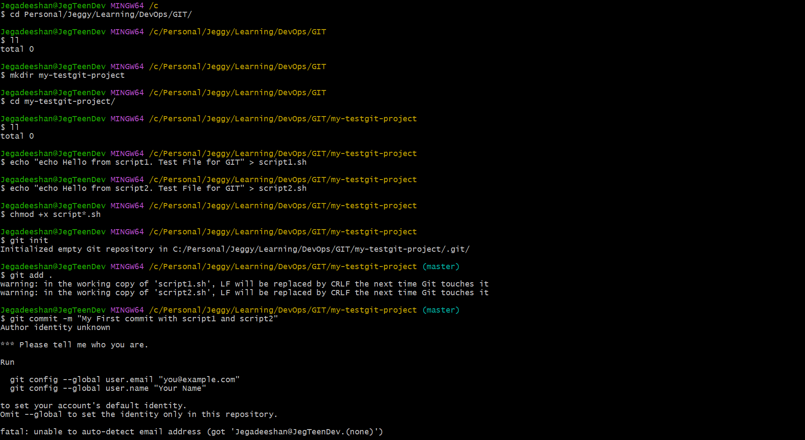

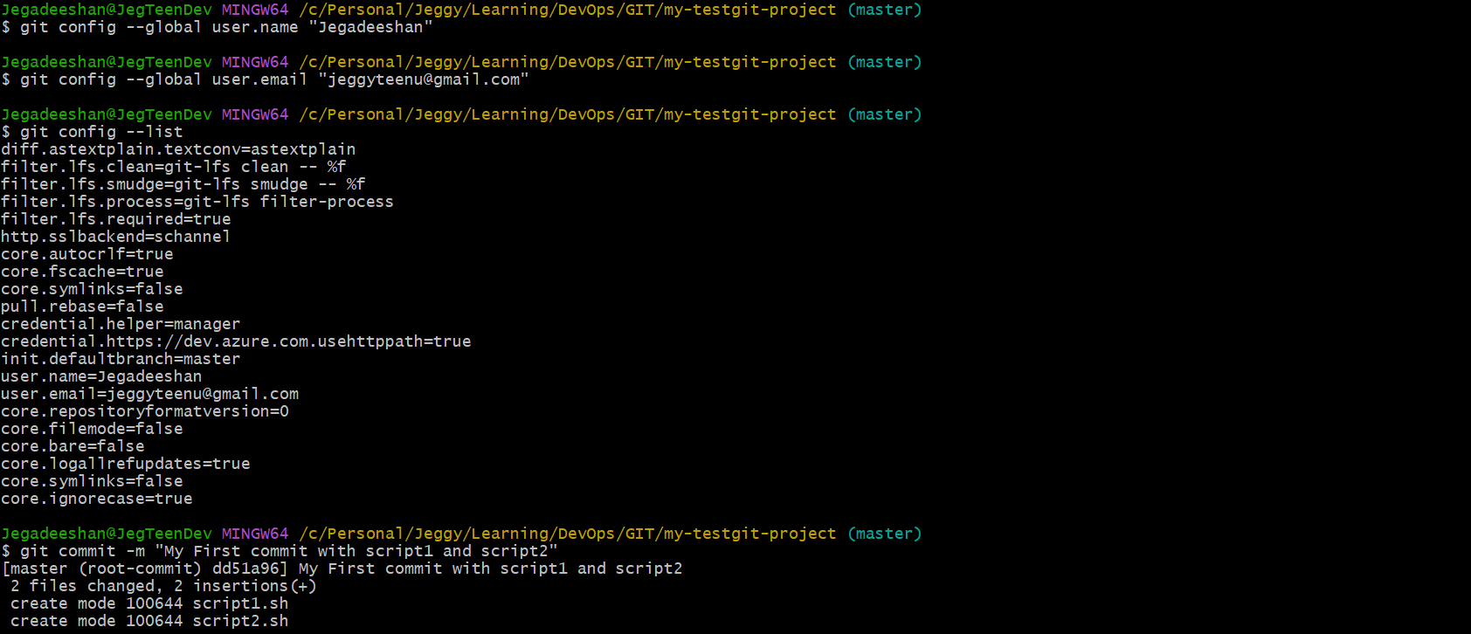

Create a new GitHub repository

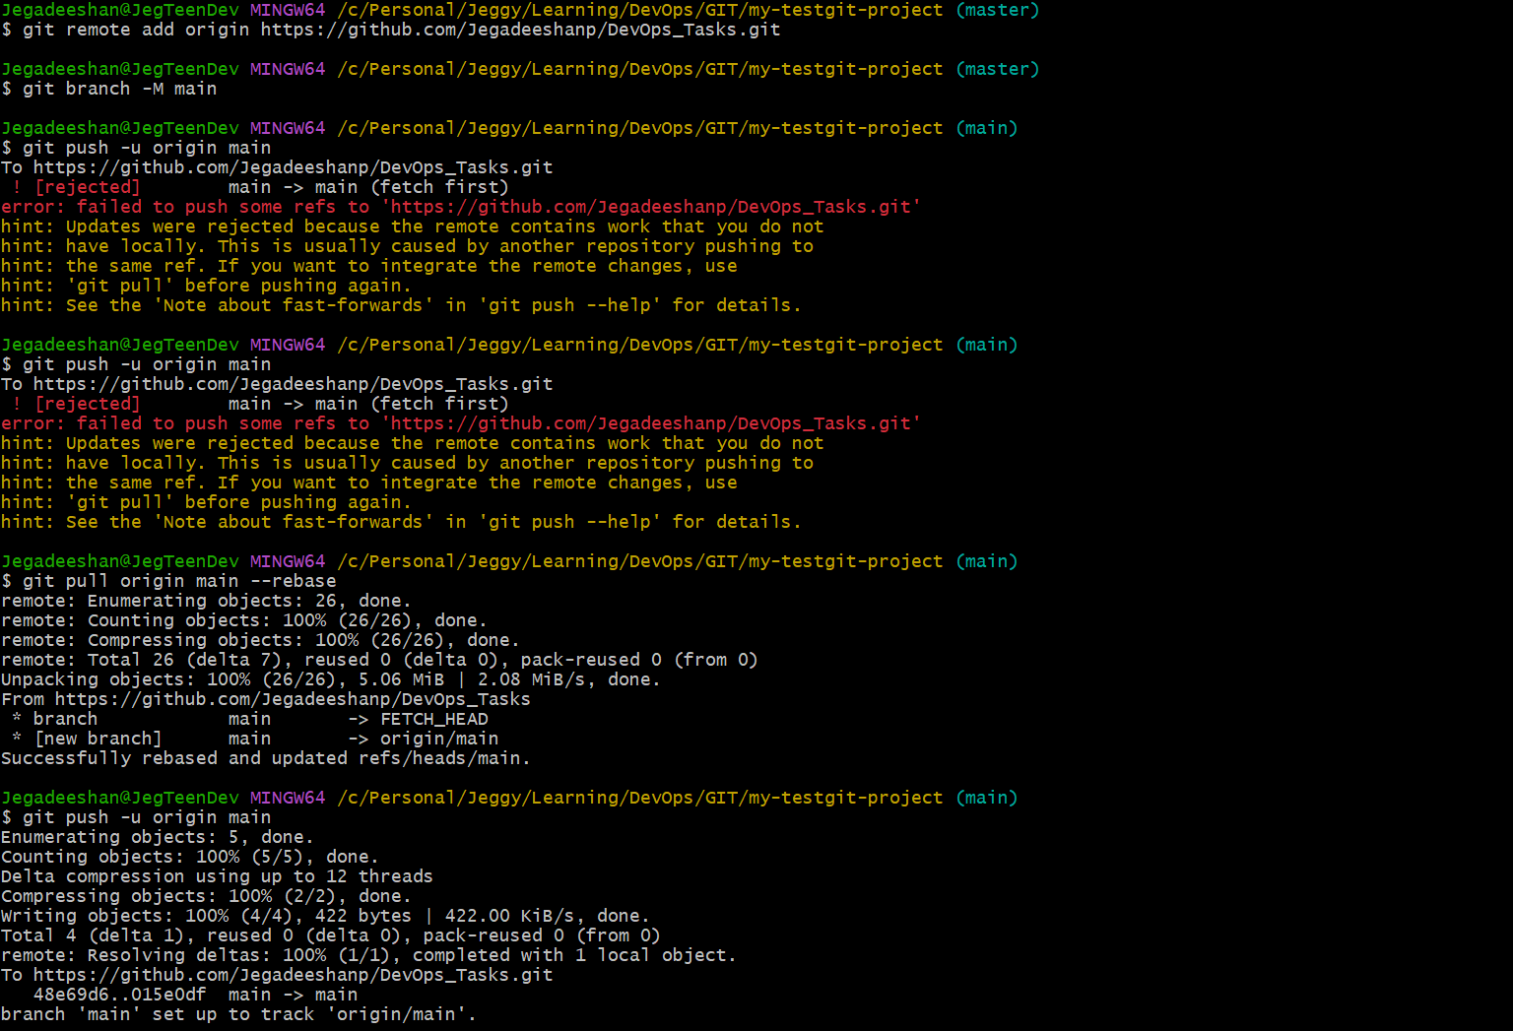

**Git Merge, Rebase, and Stash**

git checkout -b feature-branch

echo "echo Feature added" >> script1.sh

git add script1.sh

git commit -m "Feature: add echo to script1"

**Git Merge**

git checkout main

echo "echo Main branch update" >> script2.sh

git commit -am "Main: update script2"

git merge feature-branch

**Git Rebase**

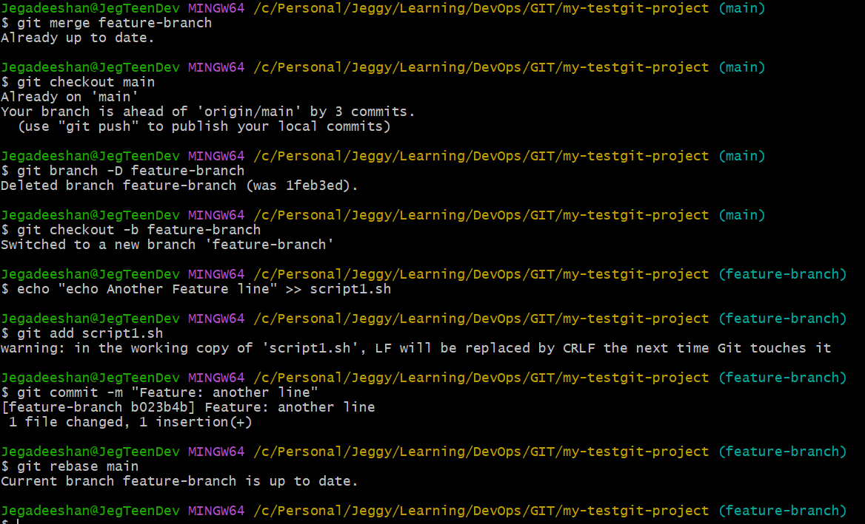

**Git Stash and Final Push**

